Family Handbook

2022 - 2023

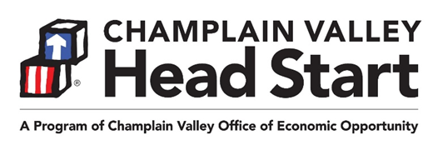

FROM THE DIRECTOR

Greetings Head Start Families!
Welcome to Champlain Valley Head Start! The year ahead will be filled with many opportunities to learn, create, socialize and have fun. Head Start is dedicated to serving children and families. We know there are many changes that take place during the early years and we want to help support your child and family through these transitions.

Head Start believes that parents are the first and most important teachers of their children. There are many opportunities for parents to be part of Head Start. We want all parents (biological, adoptive, foster parents, legal guardians) of currently enrolled children to attend Parent Committee meetings to discuss program activities and curriculum, engage in home visits, and volunteer to help with classroom activities and “special events.” Also, please consider being a part of the Head Start Policy Council, which is like a school board or “PTO” for Head Start, and offers opportunities to attend parent conferences and other statewide events. Our program offers wonderful social and educational opportunities for groups of children and parents.
Please talk with your Head Start staff person to find out the times and places of Head Start meetings and events, and bring your ideas about how you think Head Start can improve services to children and families throughout the Champlain Valley. Many of these gatherings are currently happening virtually, we are beginning to bring people together in person as we navigate our way out of the pandemic. Together we will continue to grow strong, healthy Vermont children and families.

In this Family Handbook, you will find information about what makes Head Start special, and some general information about program policies and practices. Your Head Start staff person will review this information with you, and talk with you about any questions you may have about the year ahead. Have a wonderful year in Head Start!

Sandra Graves, Director
Champlain Valley Head Start

INTRODUCTION TO HEAD START……………4
What are Early Head Start and Head Start? ….4
Who can be part of Head Start?..............………4
Head Start Core Values………………………….4
Champlain Valley Head Start Mission……...…..4
The Organization………………………………….4

POLICIES & PROCEDURES…………………...5
Confidentiality………………………………..…....5
Standards of Conduct………………...……….....5
Providing False Information on Applications…..5
Positive Behavior Support & Mgmt Policy……..6
Attendance and Participation……………………6
Permission to Pick Up / Permission to Transport Emergency Contacts……………………………..7
Child Abuse and Neglect Reporting……………7
No Smoking/Vaping Policy………………………7
Alcohol, Other Drugs and Impaired Drivers……7
Shots (Immunization Policy)………………….…8
Sick Policy………………………………………...8
Medication Policy………………………………...8 Food Policy………………………………………..9
Holiday and Celebrations Policy………………..9
Complaint Procedure for CVHS Families …….9
Additional Information about State of Vermont Child Care Licensing Regulations…………...….9
Lead Testing of Water………………………..…..9

CLASSROOM PROGRAM LOGISTICS……..10
Classroom Schedule……………………………10
Classroom Closings…………………………….10
Things to Bring (and Not to Bring)
to Classrooms ………………………………….10
Outdoor Play……………………………………..11
Sickness and Injury while at School…….….....11

HOME-SCHOOL CONNECTIONS…….….….11
Communicating with Families……………..…..11 Home Visits…………………………………..….11
Parent Teacher Conferences………….……....11

EDUCATION SERVICES……………….….….11
Play-Based Early Education………….…….…12
Screening & Assessment………………….…..12
Ready for Kindergarten? …………………...…12

SERVICES FOR CHILDREN WITH SPECIAL NEEDS……………………………………….…13
Children’s Integrated Services – Early Intervention Services for Children Birth
to Age 3…………………………………………13
Early Childhood Special Education – Services for Children Ages 3 to 5………………………..13

HEALTH SERVICES……………………………13 Physical Exams & Treatment….……………….14
Health Screenings………………………….……14
Dental Exams and Treatment………………….15
Nutrition & Nutrition Education…………………15
Nutrition Assessment…………………….……..15 Meal Service……………………………………..15
U.S.D.A. Child & Adult Care Food Program….15 U.S.D.A. policy ………………………………….27
Wellness, Mental, Emotional Health…….….…16

FAMILY SERVICES……………………………..16
Social Services Support & Referrals…………..16
Family Goal Setting & Family Partnership Agreements…………………………………..….16

PARENT ENGAGEMENT: THE FOUNDATION OF HEAD START……………………………….17
Volunteering in Head Start: We Need You!......17
Parent Committee Meetings and Activities…..17
Champlain Valley Head Start Policy Council…18
Head Start Program Advisory Committees…..
Child Care and Mileage Reimbursement……..19
Location of Parent Events………………………19

GETTING TO SCHOOL OR CHILD CARE SAFETY……………………………………….…20
Helping Head Start Keep Children Safe……...20
Safety Tips When Traveling To/From Preschool or Child Care…………………………………….20
Safety Procedures for Boarding & Exiting the Bus…………………………………...…………..21
Safe Riding Practices…………………..………22
Emergency Evacuation Procedures…………..22
Additional Transportation Safety Information
for Parents………………..……………………...22
Safety Tips When At Preschool or Child Care……………………………………………….23

ANNUAL NOTICE REGARDING CONFIDENTIAL INFORMATION & PARENTAL RIGHTS…........24

U.S.D.A Child and Adult Care Food Program…27

CLASSROOM SCHEDULE & HEAD START CONTACT INFORMATION…………………….28
Classroom Schedule……………………………28
Head Start Staff & Office Times…………….….28

INTRODUCTION TO HEAD START

What are Early Head Start and Head Start?
Head Start and Early Head Start are programs for pregnant people, families and their children ages birth to five. Head Start is for children ages 3-5. Early Head Start is for pregnant people and children from birth to age 3. Both programs include support around education, health, nutrition, mental health, and social services to help families and children grow and do well in school and in life.

Champlain Valley Head Start has programs at sites in Franklin, Grand Isle, Chittenden and Addison Counties. Head Start services are free for all eligible families, though some child care fees may apply in child care centers in which Head Start services are provided.

Who can be part of Head Start?
People who are pregnant, and families with children ages 0-5, may be able to be part of Early Head Start or Head Start if:
- the child’s family receives Reach Up, 3Squares or Supplemental Security Income (SSI); OR
- the child is in foster care; OR
- the child’s family is homeless; OR
- the child’s family meets income limits

We can also enroll some children from families that do not meet the above rules.

Head Start Core Values
At Head Start we:
- Create a place where you, your children, and staff can learn new skills and feel good about learning
- Are aware that families and staff come from many different backgrounds, and work together as a team to talk about and honor different cultures and diversity
- Encourage you to help make choices about the program by being part of Policy Council (part of Head Start’s “government”), and/or by letting Head Start know what you think about the program
- Keep children healthy and safe
- Respect all parts of your child’s growth, including social, emotional, learning, and physical growth
- Build a community in which you and your child feel like part of a group
- Connect you with area agencies that provide services to children and families
- Develop services that support you and your child after you leave Head Start

Champlain Valley Head Start Mission
The Champlain Valley Head Start mission is to provide high quality services to help children and families grow and do well in life. Our top goal is to be sure children are healthy and safe.

The Organization
Champlain Valley Head Start serves Chittenden, Franklin, Grand Isle and Addison Counties. Champlain Valley Head Start is part of the Champlain Valley Office of Economic Opportunity (“CVOEO”), a private, non-profit group that offers programs including Head Start, Early Head Start, Children’s Integrated Services, Community Action, Weatherization, Fuel Assistance, Housing Assistance programs, Emergency Food Shelves, Domestic & Sexual Violence programs and other services.

POLICIES & PROCEDURES

Our staff will talk about important Head Start information with you. Please be sure that you understand this information. Please ask questions if you do not understand. We have shortened some of the information for this handbook. Copies of the full policies are available on request.

Confidentiality
All child and family records are confidential (private) and in secure locations. Champlain Valley Head Start keeps child and family records for 3 years after the child leaves the program. After 3 years, all paper records are destroyed.

In most situations, we do not share information about you or your child with anyone outside of Champlain Valley Head Start unless you agree to it. Champlain Valley Head Start can share information with some or all of the key people below without a signed release:
- Champlain Valley Head Start staff
- Champlain Valley Office of Economic Opportunity (CVOEO) staff that work with Champlain Valley Head Start
- Child care programs, schools, and other agencies that work with (or may work with) you and your family
- Head Start consultants (dietician, mental health, tooth tutor, nurse, education)
- Other people who work with Champlain Valley Head Start, and only on a need-to-know basis
- Qualified people who are doing research, or doing a review of our program

All CVHS staff are required by law to share certain information in situations where there is suspected child abuse or neglect or risk of harm to individuals. CVHS does not need your permission to share these concerns with the appropriate authorities.

You will get a copy of your rights about information related to your child and family every year. If your child will be going to Kindergarten, CVHS will share information about your child’s educational experience with their next school unless a parent or legal guardian notifies the program in writing that they do not want the information shared.

You will sign a form if you agree that it is okay for the teacher to take pictures of your child. Sometimes we use these pictures for Head Start newsletters, brochures, posters or the Champlain Valley Head Start website and social media.

Standards of Conduct
All Champlain Valley Head Start staff, consultants, volunteers and substitutes agree to follow our Champlain Valley Head Start Standards of Conduct Policy. This means they agree to:
- Follow our Confidentiality Policy
- Never assume things about a child or family based on gender, race, ethnic background, culture, religion, family make-up or disability
- Never leave a child alone or unsupervised
- Use positive teaching methods with children and never hurt a child, physically or emotionally
- Never try to teach a child to behave by isolating them, or by using food as a punishment or reward, or by denying them basic needs
- Use truthful information to only enroll eligible children and families.

Providing False Information on Applications
When filling out the CVHS application, please be sure that all information is correct. If you provide false information, on purpose, CVHS will update your application to see if your family can still be in the program. Leaving out key information on the application will be treated the same way as if you provided false information.

If your family is re-determined to be “not eligible” due to:
- Age
- Residency (where you live)
- Pregnancy status
- Income above the current limits
….then your family will be exited from the CVHS program within 30 days.

If your family is exited because it is over the income limit, you may choose to re-apply to the program for an “over-income” space. The new application will follow the CVHS written selection process.
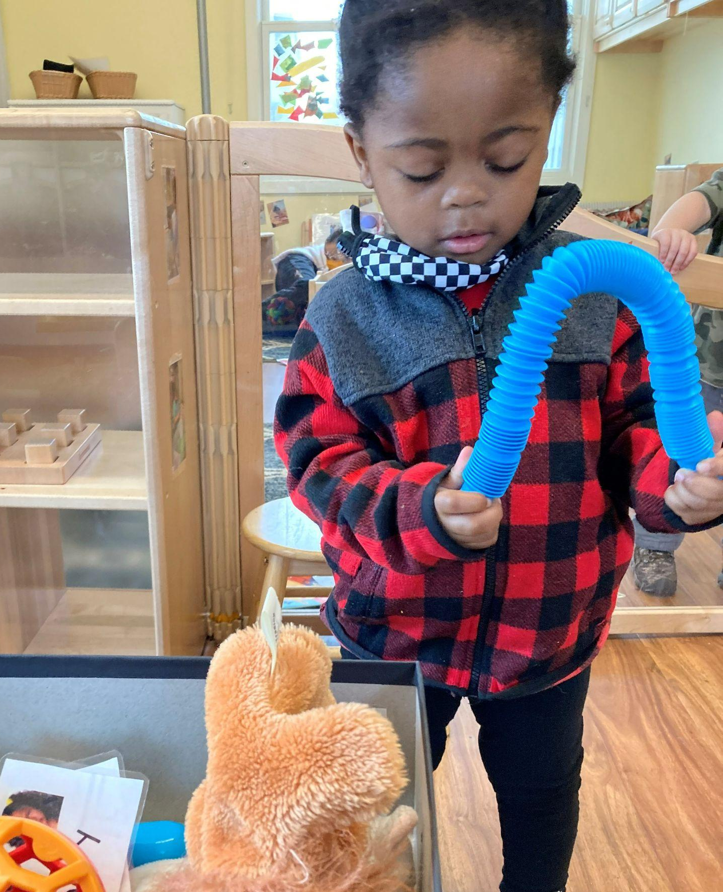
Positive Behavior Support &
Management Policy
All children learn and develop at their own pace. In early childhood, children are developing social and emotional skills and learning behavioral expectations. These skills are taught over time and require LOTS of practice, just like reading and math skills. Some children need extra support in working on challenging behavior. By this we mean behavior that isn’t working for the child, occurs often, and impacts their ability to learn and play.

We work with children to help them have better self-control. We use positive methods to do this. We might:
- Teach skills by using songs, books, games and reminders
- Show them how to behave
- Redirect them to a better activity or set limits
- Let them know what will happen if they keep doing something they should not be doing
- Provide the space or time needed to get back in control

CVHS does not suspend, expel, reduce hours or send children home because of challenging behavior.

If you have concerns about your child’s behavior at home or school, please talk with your Head Start staff person. CVHS will work with you and other people supporting your family to make a plan about how we will help your child.

Attendance and Participation
Champlain Valley Head Start wants to keep your family in our program for the full program year. When your child comes to school or child care regularly, he or she will be more successful in the classroom and be better prepared to go to Kindergarten

If your child is in a classroom, they should try to go to school every day that the program is open, unless they are sick. Children who go to child care or preschool on a regular basis are more comfortable with the group’s routine. They also know what is expected of them. With regular attendance, children are more likely to make good friends. Children who miss many days of school may feel left behind. They may miss important times for learning and being with their friends.

Parents and guardians!
Please let center staff know if your child will not be in school because they are sick or for any other reason.

We get worried if children miss a lot of school. If children have 4 unexcused classroom days in a row we will send you a letter to see if you want to stay in our program. We want to work with you if there are problems that cause missed visits. We may come up with a “Family Support Plan.” This is a plan made by you and your teacher/family support specialist that lists the ways we can support your family so you can stay in our program.

In some cases, Champlain Valley Head Start must exit families from the program. The reasons may be:
- Children not coming to school (and we don’t know why)
- Many missed home visits (with no new visits set up)
- If we can’t contact your family over a long period of time.

If this happens we will send a letter to your last known address we have on file. We also may try to find your family by talking to your emergency contacts.

Permission to Pick Up / Permission to Transport / Emergency Contacts
Each child will have an Emergency Form. You (the parent or legal guardian) filled out and signed this form when you filled out the Head Start Application. Staff will only let children leave with people you list on this form. People picking up children will need to show ID if the staff do not know who they are. Parents must fill out new forms any time they want someone new to pick up their child.

You must have two adults (other than the legal parents/guardians) listed as Emergency Contacts for your child on this form. The State of Vermont requires we have this information for every child in our program. Emergency Contacts must be able to pick up your child if there is an emergency. Please let these Emergency Contacts know you have listed them on this form.

If any parent wants to pick up his/her child, the staff must let that child leave. If there is a court order that says a parent can’t pick up a child, the staff will not let the child leave. Please be sure to share any court orders right away.

Children need to arrive and get picked up on time. If a child is not picked up on time, staff will try to contact the child’s parent or guardian. If 20 minutes have gone by and the parent/guardian can’t be reached, staff will call the emergency contacts. If staff cannot reach anyone, she/he will call the police or DCF. The police or DCF will then be responsible for the child.

Child Abuse and Neglect Reporting
All Champlain Valley Head Start staff, substitutes, consultants, and volunteers are required by law to call the Vermont Department for Children and Families, Family Services Division (DCF – FSD) if they think that a child has been hurt on purpose or neglected. Neglect can include situations where a child is at significant risk of harm due to not receiving treatment at a doctor or dentist. You will not be told if DCF has been called. We want to continue to work with you and your child even if a report is made or your family is already working with DCF – Family Services. A report to DCF will never affect your child’s connection to our program. The same is true about any involvement with the law.

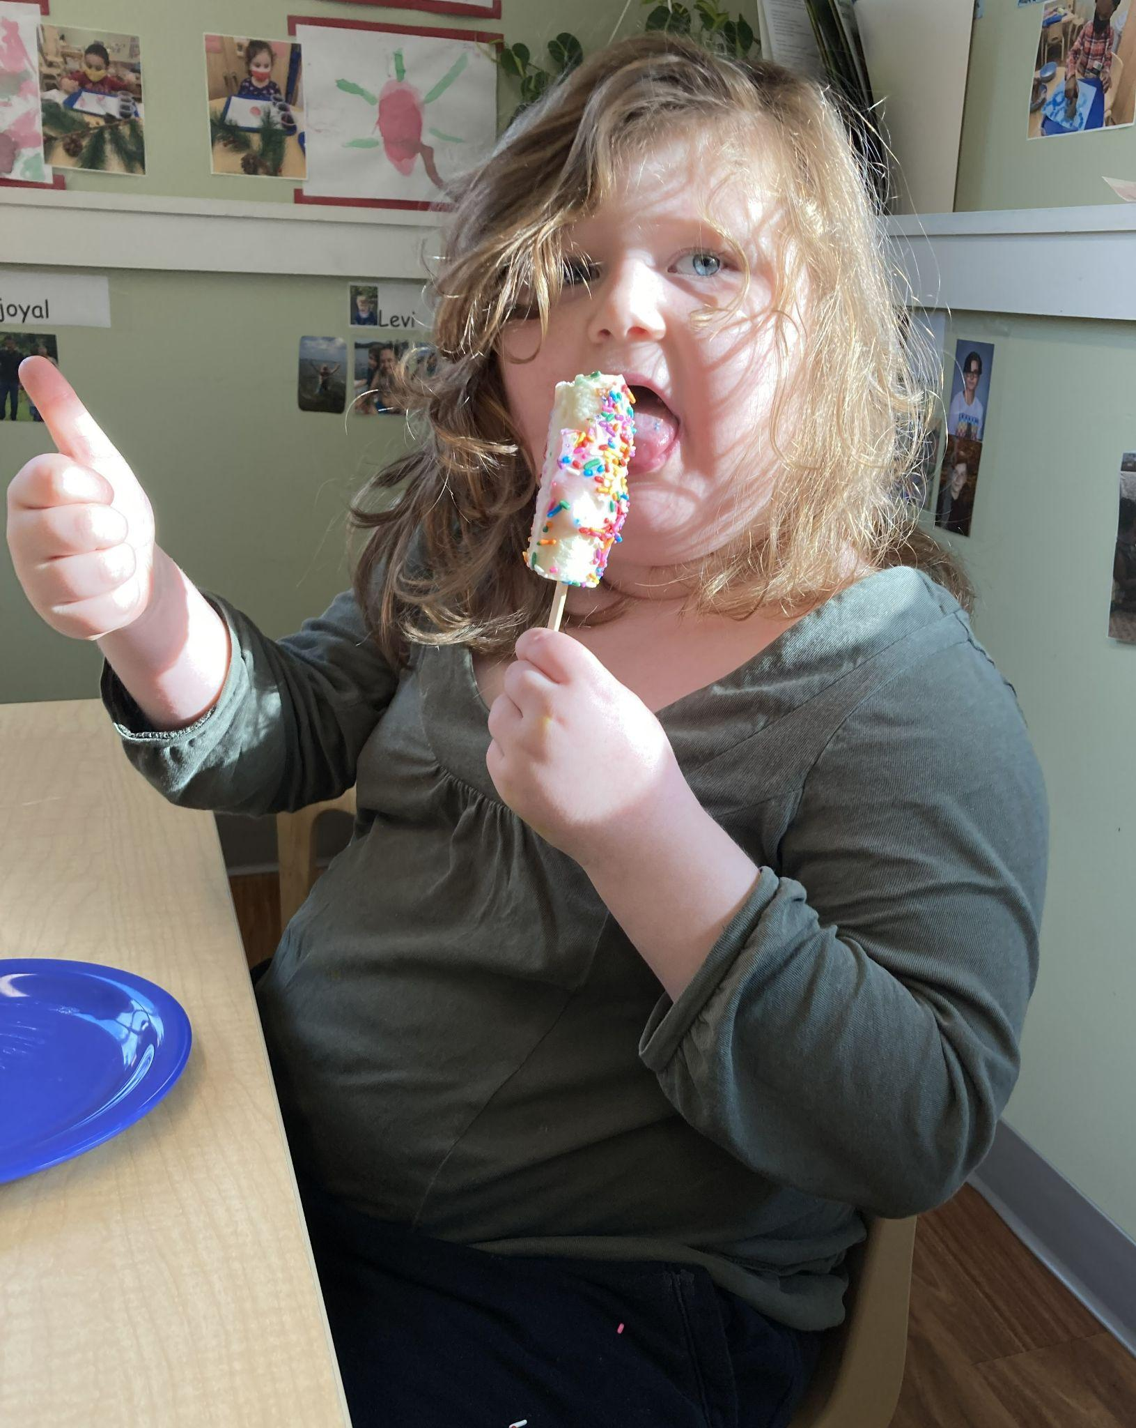
Parents/Guardians are also encouraged to call DCF-FSD if they are concerned their child is being hurt by another caregiver, including a child care provider. The number to call is 1-800-649-5285.

No Smoking/Vaping Policy
Head Start is tobacco free! There is no smoking/vaping allowed at any Head Start event or location. This includes classrooms, group activities, parent meetings, and offices.

Alcohol, Other Drugs and Impaired Drivers
Alcohol or illegal drugs are not allowed at any Head Start activity or location. If anyone comes to a Head Start event while using alcohol or drugs, they will be asked to leave. If the person does not leave, staff will call the police to assist.

Champlain Valley Head Start expects that no one will be using alcohol or drugs when staff arrives for a home visit. Head Start staff should not see any illegal drugs in the home. All staff members reserve the right to cancel a home visit if either of these things happens.

Head Start staff will contact DCF or the police if they believe that children are not being well cared for or may be at risk of harm due to a parent or caretaker using alcohol or drugs.

If someone comes to pick up a child and staff thinks that the person is using alcohol or drugs, they will call the police or DCF.

If you are concerned about alcohol or other drug use in your home, please talk to your Family Support Specialist. We can help connect you to resources for help in the community.

Shots (Immunization Policy)
Head Start believes that healthy children are up to date with their shots. Head Start staff will work with you and your child’s doctor to make this happen if your child does not have the shots they need.

Shot records must be on file by the first day of class or home visit. This is a Vermont Child Care Licensing requirement for children in child care or preschool. Head Start will try to get your child’s records from the State of Vermont before he/she starts. If we cannot get your child’s records before your child begins with Head Start, we will ask you to get them for us.

If you do not want your child to get all their shots, you must complete and sign a State of Vermont Immunization Exemption Form each program year.

Sick Policy
For the safety of all, children and their family members who are sick or who are contagious (have something that can be passed on to others), should not go to school, childcare or any Head Start activities.

Please do not bring your child to Head Start if he/she:
- Is too sick to take part in regular activities.
- Has signs of a sickness that can be spread, like: a fever (100 degrees or higher), sore throat, throwing up, or diarrhea.
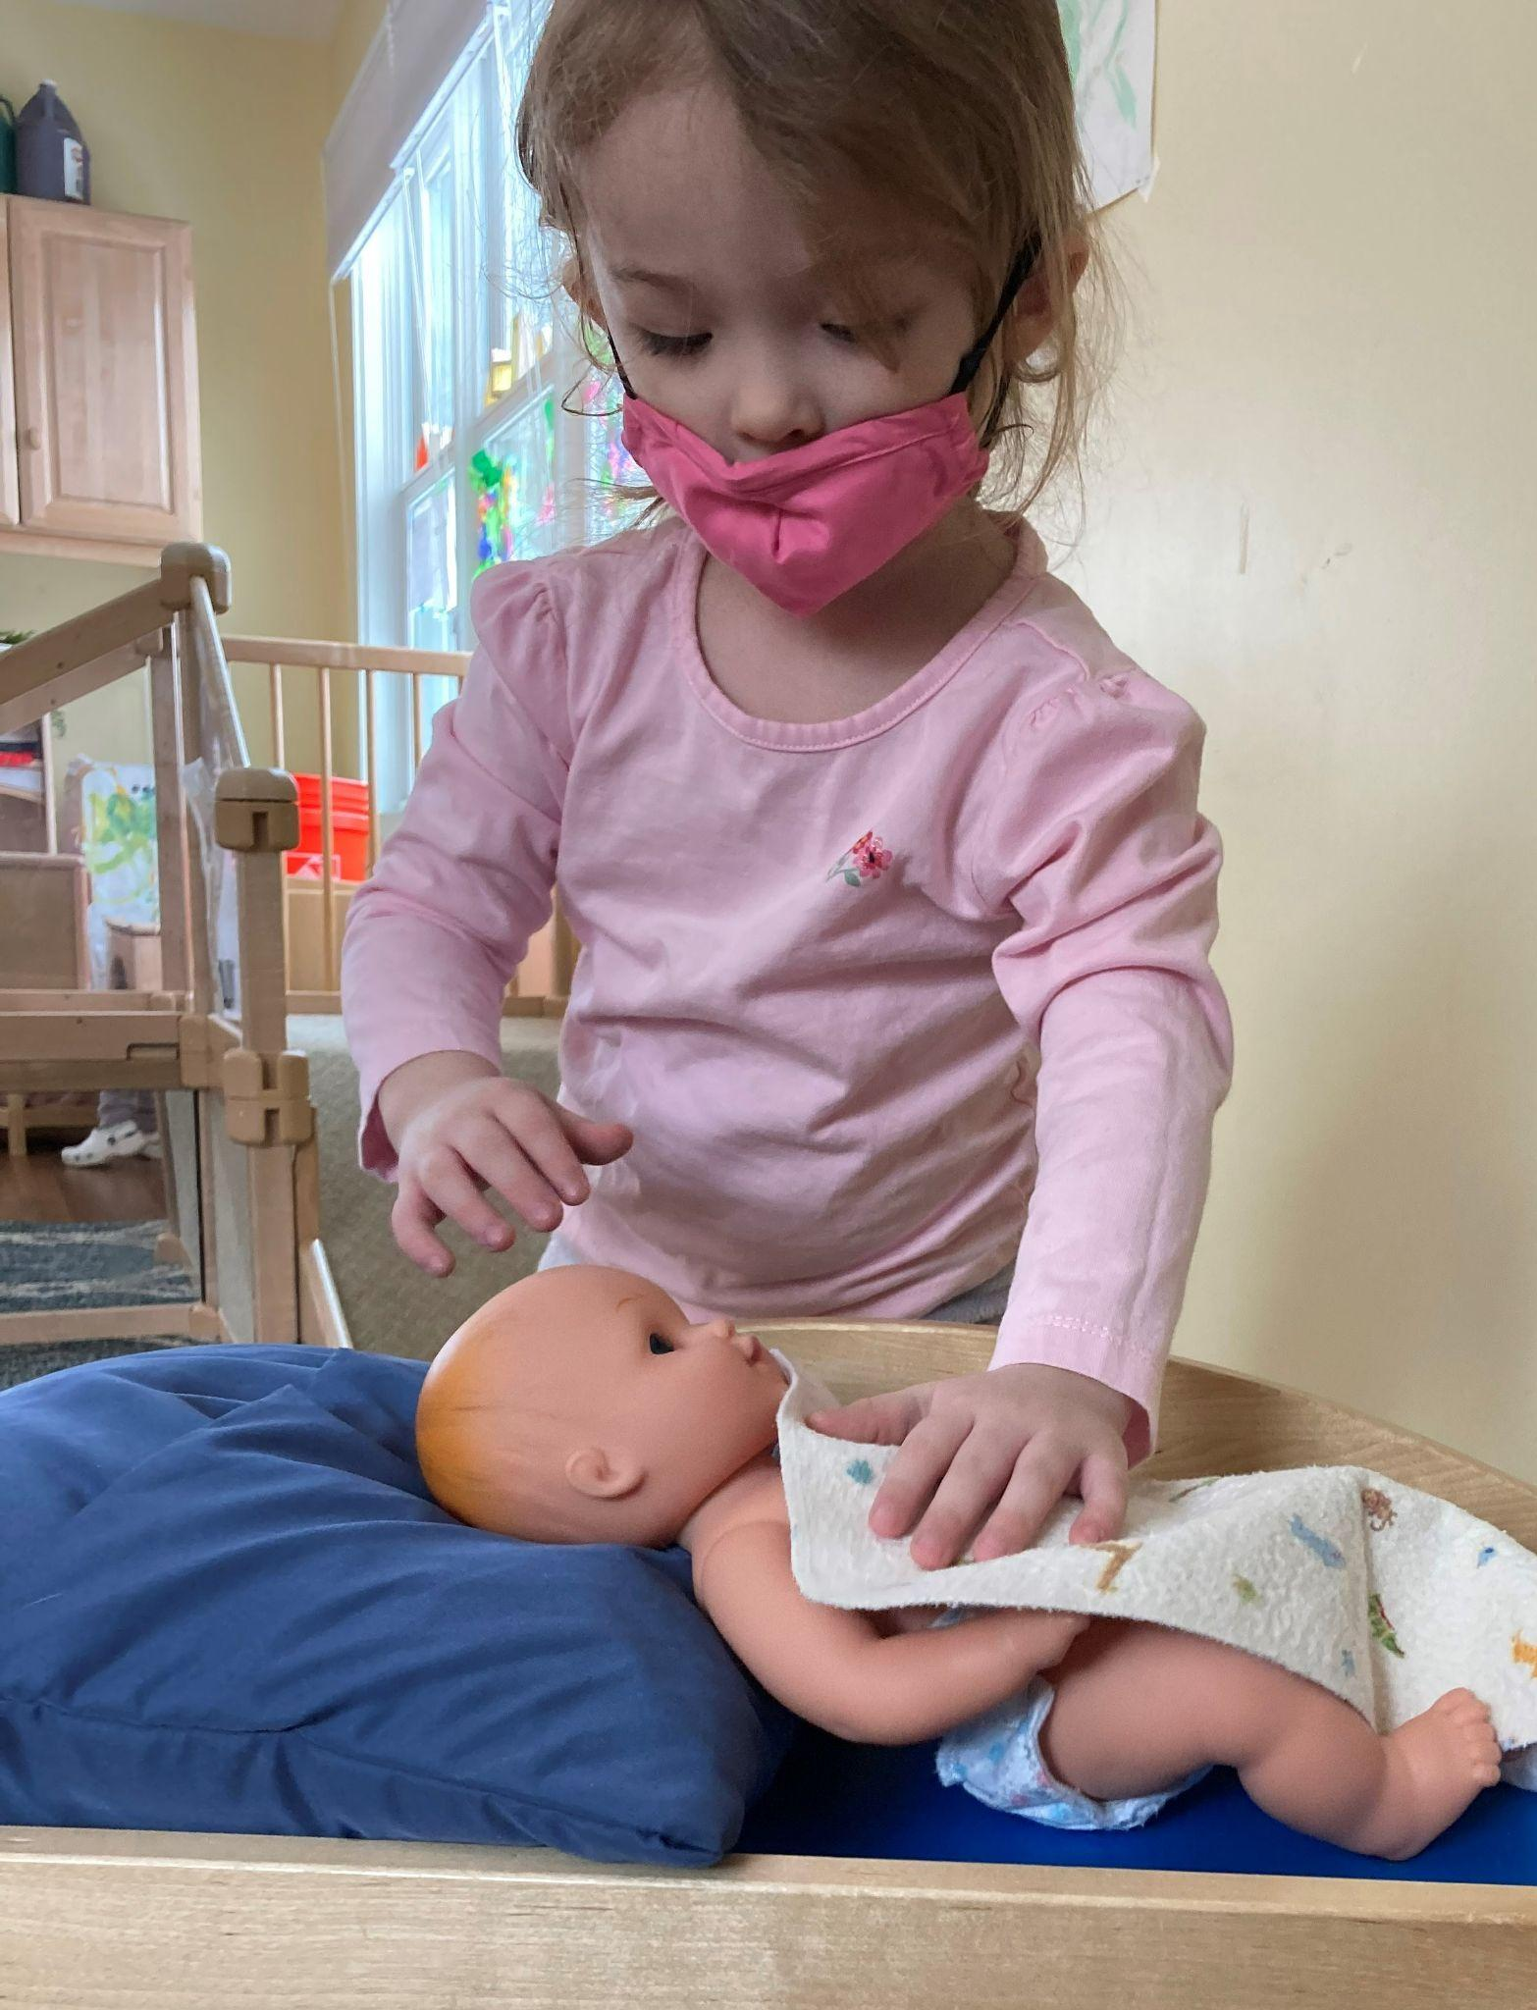
- Has something that can be given to others like: COVID-19, Chickenpox, Ringworm, or Strep Throat.

Please check with your Head Start staff person about when your child can return to Head Start if they get sick or have something they can pass on to others. Head Start follows the State of Vermont Licensing rules about keeping sick children out of the classroom. Your Head Start staff person has more information if you need it. Parents and staff with the above signs or conditions should also not come to any Head Start activities until they are no longer sick.

Champlain Valley Head Start will be following the latest guidelines for health and safety during the COVID-19 pandemic. Please refer to the Champlain Valley Head Start COVID-19 Safety Guidelines for more information.

Medication Policy
Sometimes a child needs to take medicine during school hours. This is true for both prescription and non-prescription (also called over-the-counter) medicines. Your Head Start staff person can give your child medicine as long as you do the following:
- Fill out a Medication Permission Form. We also need a note, signature, or health plan (like an asthma action plan) from your child’s doctor.
- You (or another adult) must give the medicine to your child’s teacher. Do not send it in with your child.
- All medicine must be in the original package. If it is a prescription, it must have the prescription label with it.

For “rescue” medicine (such as an inhaler for an asthma attack or Epi-Pen for a bee sting or food allergy), medicine must be in the classroom whenever your child is there. Ask your doctor for a second prescription of the medicine. You can keep one prescription in your child’s classroom and one at home, so you don’t have to bring the medicine back and forth each day. If your child has a food allergy, we will post information about their food allergy, along with their picture, wherever food is served to keep them safe.

Food Policy
Head Start gives healthy meals and snacks to children. Due to food allergies and strict Federal and State rules, families cannot bring in food to share at any Head Start activity (including classrooms, parent meetings, and group events). Head Start provides food for all children enrolled in a center-based option. The program does not discriminate under any circumstances.

Holiday and Celebrations Policy
Head Start knows that holidays, religious activities and birthdays are important parts of family life. However, we serve families with many different backgrounds and traditions. We do not want any child or family to feel that their background or tradition is not as important as anyone else's. Head Start rules say that holidays, religious days and birthdays cannot be observed at any Head Start event or classroom. Instead, Head Start will celebrate the changing seasons during the year. You can celebrate holidays and birthdays with your Head Start staff during home visits.

Complaint Procedure for Champlain Valley Head Start Families
Champlain Valley Head Start offers you a high-quality program, but sometimes you may have concerns. It might be about the classroom days or times, or maybe about someone who works with your child. Talk to your Head Start staff person first. Also, you can contact the County Supervisor for your program. The Champlain Valley Head Start Director and Area Coordinators (health, education, family services, mental health, disabilities, and enrollment) can also help you. Please call us with any questions, 1-800-854-9648.

Additional Information about State of Vermont Child Care Licensing Regulations
All Champlain Valley Head Start classrooms follow the State of Vermont Child Care Licensing Regulations. A copy of these regulations is available in the classroom or by visiting this link:

https://dcf.vermont.gov/sites/dcf/files/CDD/Docs/Licensing/CBCCPP_Regulations_FINAL.pdf

Child Care Consumer Line
Call 1-800-649-2642 toll free in Vermont to:

- Get information about child care providers (e.g., when they became licensed, if they are accredited or have a STARS rating, and if they've had any licensing violations in the past year);
- Voice a concern about a provider (e.g., unregulated, lack of supervision, too many children, unqualified or not enough staff, inappropriate guidance and discipline, unsafe environment)
- Make a formal complaint about a child care provider.

Lead Testing of Water
All Champlain Valley Head Start classrooms follow the State of Vermont’s Child Care Licensing Regulations. Lead is a harmful substance that can make people very sick, especially children. Vermont law requires that we test all water taps used for drinking, cooking and tooth brushing for lead.

You can find the results of water testing here: https://leadresults.vermont.gov/

CLASSROOM PROGRAM LOGISTICS

Classroom Schedule
Teachers will provide you with a copy of the daily classroom schedule and the yearly calendar. Please ask for an additional copy if needed.

Classroom Closings
- Check the classroom calendar for days your child will not have class.
- Mark your calendar to note changes to the normal class schedule.
- Each classroom usually follows the local public school’s schedule for bad weather closings. For example: if Burlington Schools have a snow day, our classrooms at Riverside and Franklin Square are closed, too. Closings are usually announced on the radio before 7:00am.
- Your teacher and/or family support specialist will contact you through TalkingPoints messages about any unexpected closures.

Things to Bring (and Not to Bring) to Classrooms
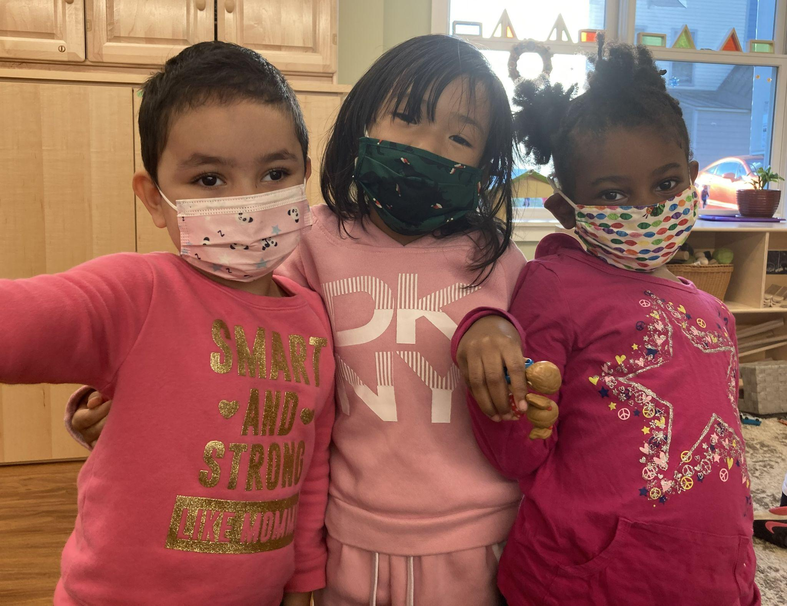
- Please keep two extra sets of clothing for your child at school at all times. If your child gets wet or very dirty, he/she can change right away for comfort. Include a pair of pants, a shirt, a pair of underpants, and socks. Please label the clothing.
- If your child is using diapers, we will provide the diapers while they are in our care. Please let your Head Start staff member know what size your child will need. We supply diapers and wipes, but the brand may vary. If your child prefers a specific brand, you will have to bring them in yourself. If there is a medical reason why your child needs a specific brand, please let us know. We do not supply pull-ups unless they are needed for medical or other reasons (other than potty-training). Please check with your Head Start staff person if you have questions
- If your child drinks formula, we will provide formula while they are in our care. The brand may vary and may not be the same you use at home. If your child prefers a specific brand, you will need to bring in your own formula. If there is a medical reason why your child needs a specific formula, please provide a note signed by your child’s doctor with the instructions on what formula is needed. In addition, we provide bottles for your child. However, we may not be able to accommodate the brand and/or style of bottle your child is used to. Please talk with your Head Start staff person if you have questions.
- Please send your child to class clean each morning. Children like to feel good about the way they look.
- Please send a tote bag or backpack with your child every day. Your child’s name needs to be marked on the bag. The bag is used to send artwork and notes home, so make sure to check it every day.
- It is important to dress your child for weather conditions. When it is winter, please remember mittens, boots, hat, warm coat, and snow pants. Children will be playing outside each day unless there are severe weather conditions. Please do not dress your child in sandals, clogs, or slippery dress shoes. Sneakers are much safer.
- Children are not allowed to bring toys, money, food, drinks or candy to school.
- If your child is allergic to food or medicine, please write this information down and give it to our staff. We want to be sure your child is safe in our classroom.
- If you have ideas for classroom activities, please let our staff know.

Outdoor Play
It is important for children to learn outdoors even in all kinds of weather. Children go outside every day, unless it is too cold (risk of frostbite), too hot, or there is a thunderstorm. We will take extra steps to keep children safe in the sun when they are outside between May and September.

Sickness and Injury while at School
If your child becomes sick or injured while at school, we will ask you to pick him/her up as soon as possible. If we cannot reach you, we will call your emergency contact person(s) (ID will be requested). If your child needs emergency care, we will take him/her to the hospital while trying to find you.

HOME-SCHOOL CONNECTIONS
Communicating with Families
Head Start teachers and family support specialists will be in regular contact with you about your child’s learning and family needs. Head Start will communicate with you in the following ways:
- Telephone
- Email
- Text messages/TalkingPoints messages
- Notes in your child’s backpack
- Regular newsletters
- Parent meetings
- Closed Facebook groups

We strongly recommend you download the TalkingPoints for Parents app available for free for iPhones and Android devices. Please update your phone numbers with a staff member anytime it changes.

Families will also be enrolled in a new text-based program called Ready4K. You will receive text messages several times a week with ideas and activities to help support your child’s growth and development. You can choose to opt-out of receiving these messages anytime.

Home Visits
The purpose of the home visit is to help you set your home up as a learning environment and foster the growth and development of your child. You will be your child’s teacher long after your child leaves our program. We want to help you think about how to make the most of this important role.

There may be times when a home visit needs to be held by computer and/or telephone. Talk with your home visitor or family support specialist if you have concerns about accessing technology.

Parent Teacher Conferences
Your child’s teachers will meet with you at least two times each year to discuss your child’s learning and progress. This is a great opportunity for you to ask questions, share feedback, and learn ways you can help your child continue learning at home.

If your family or staff are unable to meet in person, we will meet by computer and/or telephone. Talk with your family support specialist if you have concerns about accessing technology.

EDUCATION SERVICES

Play-Based Early Education
In Head Start and Early Head Start, our goal is to help your child grow and develop. We know that you are your child’s first and most important teacher. We believe that young children learn best when they play. Children learn by exploring, trying new things and asking questions. When children play, they use their imaginations, bodies, power of choice, and problem solving skills. This helps them to become good learners.

In Head Start we focus on areas of child development:
- Social and emotional
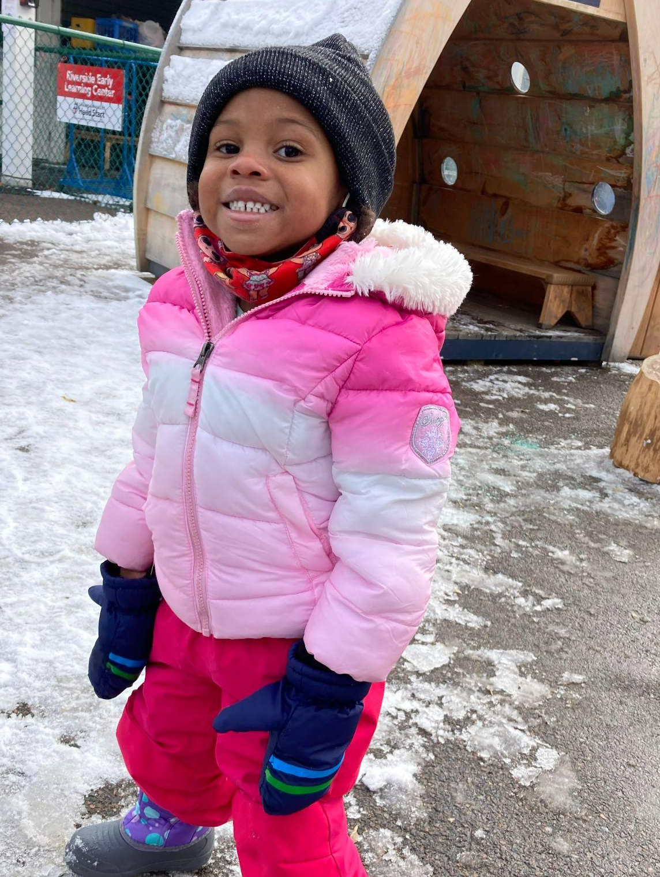
- Different ways to learn
- Language and Literacy
- Physical development
- Logic and reasoning
- English (if your family’s main language is not English)
Champlain Valley Head Start provides activities to help kids develop in all of these areas. Your child will have fun and learn new skills at the same time.
During the COVID-19 pandemic, Parents and Guardians are not able to visit the classroom when other children and families are present. Please talk with your family support specialist or teacher if you would like more information about the classroom.
Screening & Assessment
Soon after your child starts in our program, your Champlain Valley Head Start staff person will do a screening with you and your child. There are questionnaires that you will fill out letting us know about the things your child can already do. This short screening is to help show any areas where he/she may need some help or more practice.

Three other assessments are done each year (4 for Early Head Start) using Teaching Strategies GOLD. These are not tests, but help us to know your child better so we can better meet their needs. We will ask for your help to complete these assessments because you know the most about your child. All of this information is used to make Home Visit and Classroom Plans, and to be sure our activities help your child to grow and learn best.

Ready for Kindergarten?
Children are more likely to do well in kindergarten (and beyond) if they have been with a group of children and learned from adults outside of the family. They will have practiced things like joining a group, taking turns, or getting help from others. In Head Start, your child will have the chance to do these things.

The skills that most affect how well a child learns in school are:

Self Control: The ability to make decisions about how and when to express feelings and control our actions; developing inner control

Confidence: Believing in oneself and feeling successful
Curiosity: A sense that finding out about things is good and fun.

Intentionality: Setting a goal and working on it

Relatedness: A sense of belonging; connecting to others

Capacity to Communicate: Having the ability and desire to share ideas and feelings with others either with words, gestures, or movements
Cooperativeness: The ability to balance one’s own needs with someone else’s needs.
Supporting you as your child’s best teacher is part of our goal at Head Start. Over the year, we will help you to:
- Help your child feel good about their play
- Observe your child to see if there are skills that need more focus
- Come up with parenting methods to improve behavior
- Provide health and dental care to keep your child healthy
- Use things around your home to help your child learn
- Help your child do well when they go to kindergarten

SERVICES FOR CHILDREN WITH SPECIAL NEEDS

Champlain Valley Head Start works with community professionals to provide services and support to children with special needs. All Head Start and Early Head Start services, including all center activities, group events and field trips, are open to all children, with or without special needs.

For children who are not enrolled in special education services, Champlain Valley Head Start staff will do a child development screening shortly after enrollment. The screening, called the Ages and Stages Questionnaire, is completed by you. The information you give will:
- show the things that your child does well
- show any areas of concern
- help our staff find areas to focus on with you and your child.

This questionnaire, along with input from you and our staff, allows us to see if a more in-depth evaluation should be done. If staff and parents agree that more should be done, we will help you meet with the right agency to do it. Champlain Valley Head Start staff will offer support during the whole process. If the evaluation shows that your child can receive special services through ECSE or CIS (see below), we will help you learn about these services and take part in making a plan to meet your child’s needs. We will work together with you and the other service providers to follow this plan.

Children’s Integrated Services – Early Intervention Services for Children
Birth to Age 3
CIS Early Intervention programs provide services to children from birth to age three and their families.This program serves children who have developmental delays or a health condition that may lead to a developmental delay. Program services are provided at your home or at your child’s school. Some examples of services include assistive devices, family support and training, home visits, nutrition services, physical therapy, occupational therapy, and speech and language therapy.

If your child still needs services when they turn 3, they will transition to the EEE program. Early Head Start staff will work with you, starting up to six months prior to your child’s third birthday, to move from CIS to EEE.

Early Childhood Special Education –
Services for Children Ages 3 to 5
Early Childhood Special Education [EEE] is special education and services for children ages three to five years old. Your local school district provides these at no cost to parents. Special education is instruction that meets your child’s unique needs. Related services are services a child needs in order to benefit from special education, such as physical therapy or speech therapy.

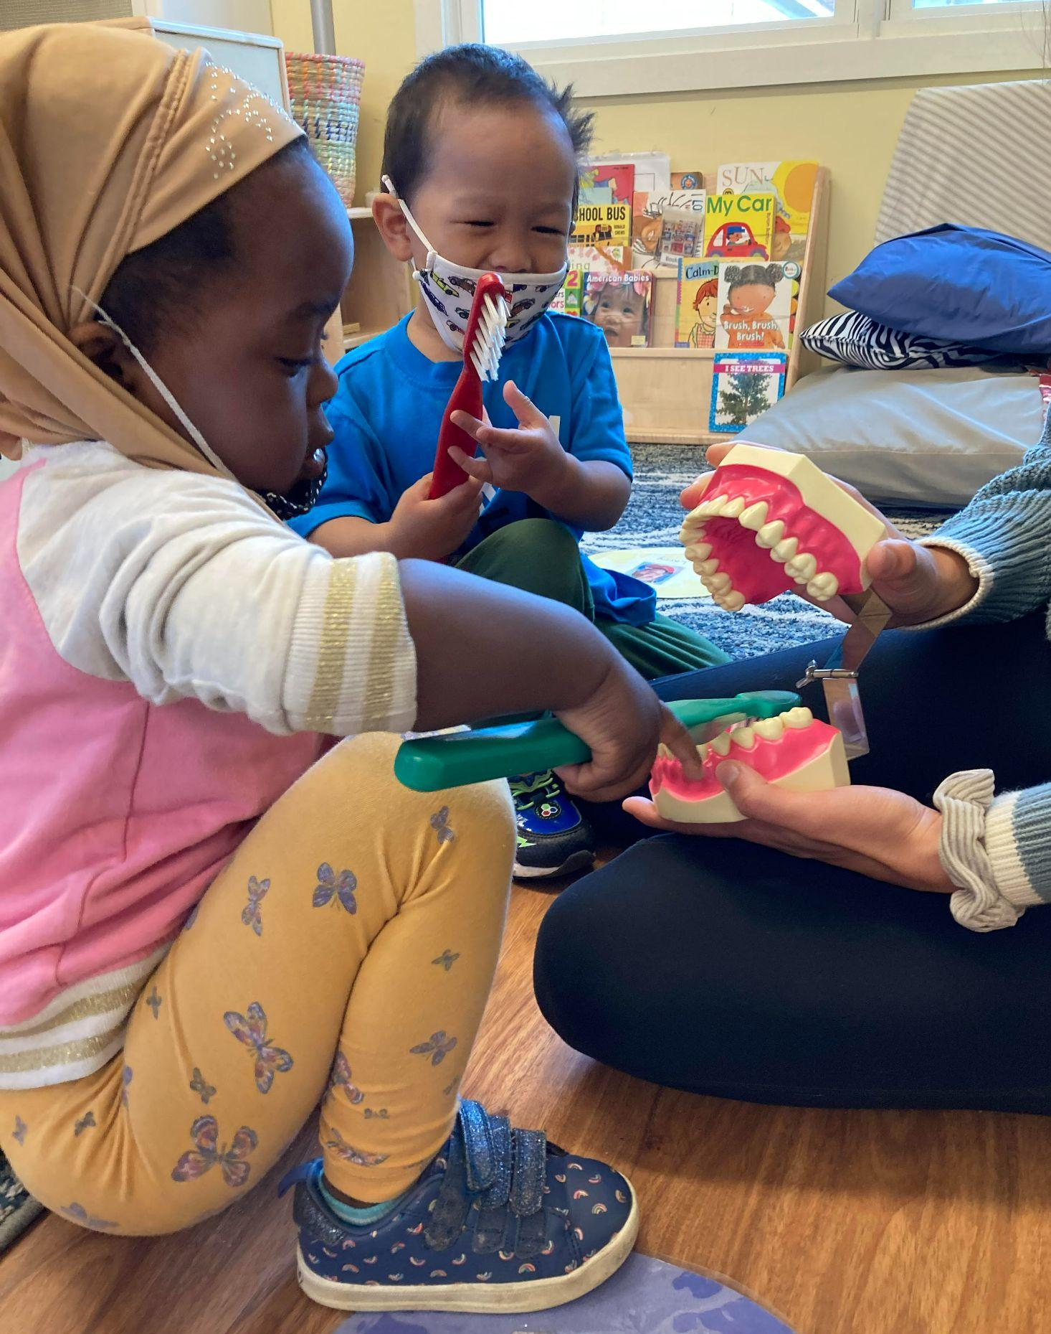

HEALTH SERVICES

The Head Start program is a full model of services which include: Education, Family Services, Special Needs, and Health Services (medical, dental, nutrition, and mental health). All of these different pieces together support the overall health and wellness of children and families. Head Start believes that the health and well-being of every child and family is important. We also believe that parents play an important part in keeping their child up to date with health and dental exams.

If your family does not already have health insurance, Head Start will help you to apply for public health coverage programs like Dr. Dynasaur. If your child is not eligible for these programs and has no insurance, we will try to help. We may be able to help pay for well-child visits and follow-up treatment that is needed while the child is enrolled in Head Start.

Physical Exams and Treatment
Vermont Child Care Licensing requires children to be up to date with physical exams, based on their age, within 45 days of enrollment. Physical exams, also called well-child exams, are visits your child has with their doctor when they are not sick. Sometimes they will get shots at these visits, but not always. We follow the State of Vermont’s rules about what ages children need a physical exam:

Age of child for Physical Exam
(Well-Child):
1 month ✓
2 months ✓
3 months ✓
4 months ✓
6 months ✓
9 months ✓
12 months ✓
15 months ✓
18 months ✓
24 months ✓
30 months ✓
36 months ✓
4 years ✓
5 years ✓

If your child has not had the required well child visit, we will help you make and attend a visit so your child will be up to date. Head Start will call your child’s doctor to get the results of his/her last physical exam before your child begins our program. If your child has a physical exam during the school year, we also get these results so we know what happened during the exam.

If your child’s health provider says that your child needs more treatment (extra care or medicine for asthma, an allergy, or something else), we will work with you to make sure that treatment is received. If your child has a health condition, we will work with you to make a health plan for your child’s teacher to use in the classroom. These plans are very important for children who have asthma and need inhalers, allergies that need Epi-pens, and seizures.

Health Screenings
A health screening can help find out if a child needs more testing by their doctor or another health professional. Within the first 45 days of starting our program, Head Start staff will do vision and hearing screenings on all children who have not had one within the last 6 months. We will let you know the results of these screenings, and if any follow-up is needed.

Vision Screening
For children over 6 months of age, we use a Spot Vision Screener that can predict how well your child’s eyes work. It also checks to be sure the two eyes are working together. For children under 6 months of age, we will ask you questions about the child’s vision to determine if any follow-up is needed.

Hearing Screening
We use a machine called an OAE to check the hearing of children of all ages. This machine uses a small ear bud and plays low sounds. The machine tells us if the child’s ears are working well. Children in Early Head Start are screened using the OAE machine. Head Start children may be tested with the OAE or an audiometer. The audiometer uses headphones that make different sounds to see how well your child hears.
We will also find out if your child was tested for lead and anemia (low iron) before they came to Head Start. Many times, these tests are done at 12 and 24 months of age. They may have been done at a WIC visit or by your child’s doctor. If you know that your child has not had these screenings, you can ask your child’s doctor to do them during their physical exam or at another visit.
Dental Exams and Treatment
Another one of Head Start’s main goals is that your child is up to date with dental exams. It is recommended that all children visit the dentist every six months beginning at age 1.

If your child does not have a dentist, a Head Start staff person, or one of our Tooth Tutors (dental hygienists) can help you find one. The Tooth Tutors are available to help you keep your child up to date in visiting the dentist every six months for an exam and preventive care (cleaning and fluoride). The Tooth Tutors will call your child’s dentist to get the results of his/her last dental exam before your child begins our program. If your child has a dental exam during the school year, we also get these results so we know what happened during the exam.

Tooth decay can start when a child is very young. Preventing decay is the key to good dental health. Starting when the first tooth comes in, brush your child’s teeth two times a day. Your child will need your help to brush their teeth until age 8. Children in our classrooms, with adult help, brush teeth every day. Classroom Toothbrushing may be suspended during a pandemic. Please help your child brush at home in the morning and before they go to bed.Tooth Tutors are available to answer any questions you have about your child’s teeth or going to the dentist.

Nutrition & Nutrition Education
Head Start and Early Head Start can help you and your child make good food choices. This is done by:
- looking at what your child eats (a nutrition assessment)
- nutrition education
- children’s classroom activities include working with healthy foods
- parent information about good nutrition (workshops or written)
- providing healthy meals and snacks for children in our classrooms

Head Start will also weigh your child and see how tall they are two times each year. We want to be sure that your child is growing in a healthy way.
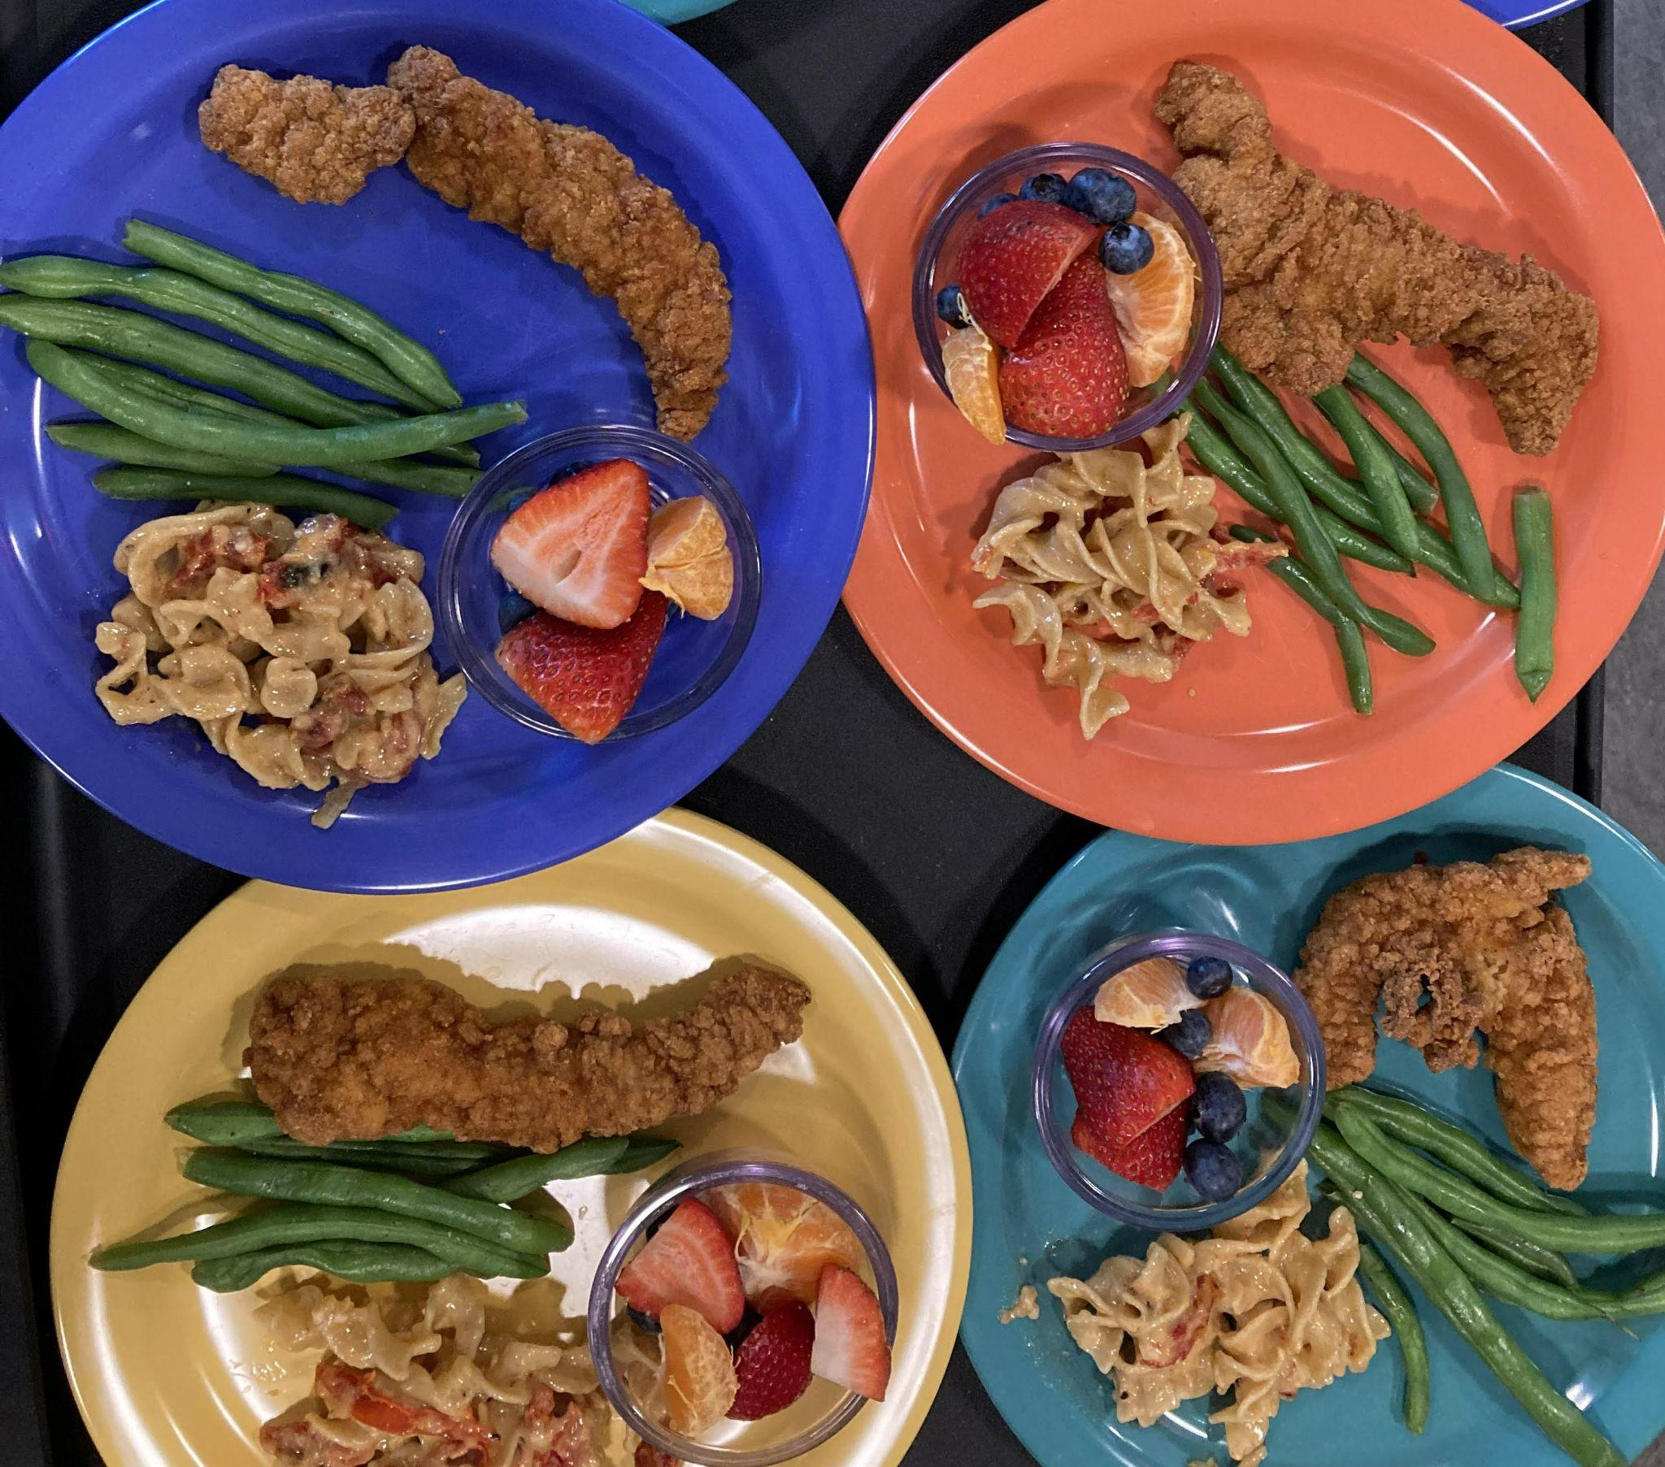

Nutrition Assessment
A nutrition assessment is done for every child.
- Parents and staff do the assessment together.
- If there are any concerns, your staff person will discuss them with you.
- We are happy to connect you with a Nutritionist or Registered Dietician if you have questions about food choices and nutrition.
- Please let us know about eating problems or nutrition concerns that come up during the year.

Meal Service
Toddlers and Preschoolers
Head Start staff and parents plan meals to be healthy, and low in salt, fat and sugar. The menus are made so that children can try some foods that they may not have tried before.

During COVID-19, meals will be served by staff to children. Children and adults will be spaced at safe distances and adults will wear masks and gloves while serving children.

U.S.D.A. Child and Adult Care Food Program
Champlain Valley Head Start participates in the U.S.D.A. Child and Adult Care Food Program. All enrolled children are eligible for free meals and snacks. The program does not keep any eligible children from participating and follows the policy listed at the end of this handbook.

Wellness, Mental, and Emotional Health
Mental Health is an important part of good overall health. Head Start works with professionals in our community to support the mental health of our families. Our mental health consultants visit classrooms and other group events to be sure they are good environments for all children. Mental health consultants are available to set up a meeting with you to connect you with ongoing support. These professionals are available to go on home visits with parents.

Parents may wish to meet with a mental health consultant for help with:
- Responding to the challenging behaviors of their children
- Recognizing the signs of depression in children or adults
- Conflict between siblings
- Substance abuse concerns
- Physically or emotionally abusive relationships
- Incarceration of a family member
- Major changes to a family structure such as death or divorce
- Other parenting or family relationship issues

FAMILY SERVICES

Social Services Support and Referrals
We believe that all children and families have strengths that can help them be successful. We also know it can be hard to raise a family with young children. Champlain Valley Head Start wants to help families grow and find the support and resources they need. We help families identify family, friend and community resources. Those resources will look different for each family because of their needs and cultural backgrounds. We find the best way to help families is through consistent, two-way, open and honest communication. Head Start works to build supportive, caring, and respectful partnerships with parents that focus on their abilities. Together we help families build resources so every child has the best chance for success in school and life.

Social service needs are different for every family and could include help finding resources for:
- housing issues
- fuel assistance
- transportation
- health services
- alcohol or substance abuse services
- domestic violence services; or
- other social service issues

If you need help with something right away, please call 2-1-1. This statewide hotline can provide information and referrals to connect you with resources in your community.

Family Goal Setting and Family Partnership Agreements
When you think about what you would like for your child and family in one year, two years, or even five years, you are thinking about family goals. Champlain Valley Head Start can help your family set goals and work towards making them happen. We call these Family Partnership Agreements and we use them to help families in figuring out their strengths and challenges, set goals for the future, and make plans to meet those goals. These goals are identified and developed by you for your family. They could include things like reading with your child every day, finding better housing, learning computer skills, making a household spending plan, or cooking more meals at home. Your Head Start staff person is available to support you in making plans to meet your goals. She/He will check in with you during the year as you make progress toward completing your goals.

PARENT ENGAGEMENT: THE FOUNDATION OF HEAD START

Head Start believes that parents/guardians are important partners in a child’s education. Please read this section of the handbook to find out the many ways you can make a difference for your child. Every parent and family has different experiences, talents, and ideas, and we welcome your input in whatever way works best for your family.

Volunteering in Head Start: We Need You!
Champlain Valley Head Start wants parents to volunteer in any way they feel comfortable. There are a variety of volunteer opportunities that help our program run effectively. Volunteering in the program is a good way to learn skills and gain knowledge that may give you the experience you need for future employment. Volunteering is also a great way to be part of a supportive community that serves children. Here are just some of the ways you can volunteer in Head Start. During COVID-19, all volunteer opportunities are done at home or by phone/computer.

Partners in Education (In-kind) - Work on activities at home based on the goals you set for your child. Your time doing these activities helps make sure Head Start funding continues!

Participation in Parent Committees or Policy Council - Attend virtual Head Start Parent Committee or Policy Council meetings. Share your experiences or opinions to help make our program better!
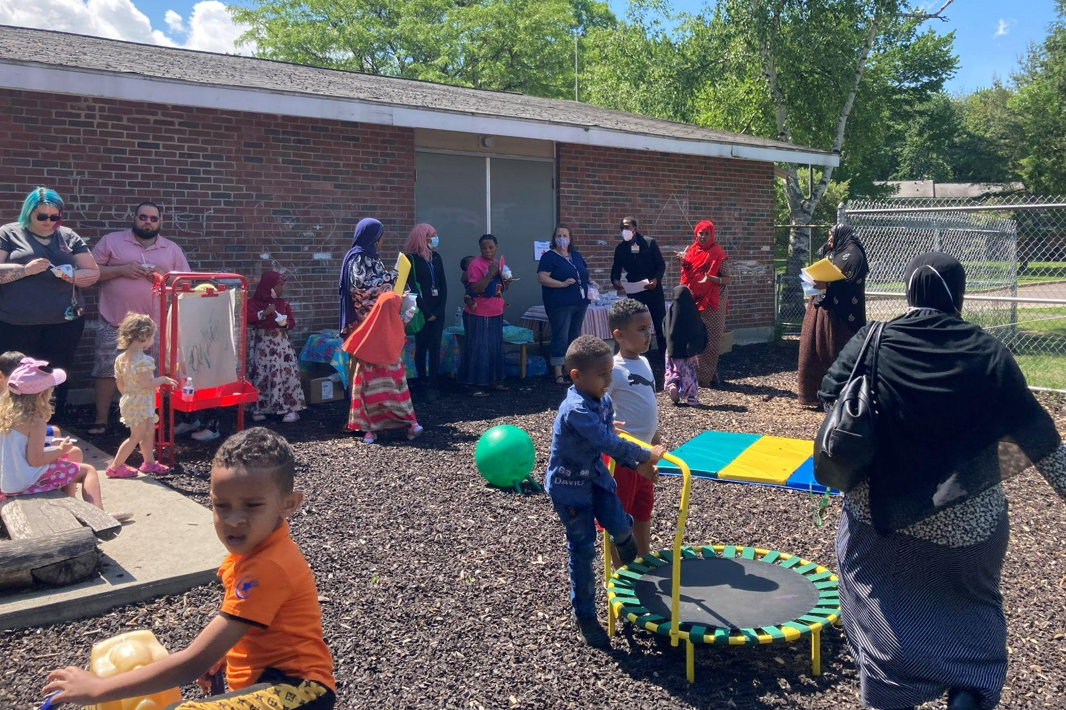
Family Activities - Share ideas with your home visitor about activities you would like to see Head Start offer so families can connect with each other and their community.

Legislature - Talk with people who make the laws, and share your experiences and needs.

There are many ways for parents with all levels of skill and time to help at Head Start. Please talk to your Head Start family support specialist or call the Family Services Coordinator at 1-800-854-9648 x 202 to talk about what you would like to do.

Parent Committee Meetings and Activities
Each Head Start program option has a Parent Committee. As a parent or guardian of a Head Start child, you are automatically part of the Parent Committee for your classroom, center, or home visitor group. Participating in the Parent Committee and Activities is very important to Head Start. We need parents to attend Parent activities to make our program the best it can be for the children! Parent Committee meetings and activities are scheduled throughout the year and at times that are convenient for parents.

Parents come together by computer for Parent Committee meetings to talk about their children, Head Start education and activities, community issues, and family issues. Parents work together to have fun, support each other, and make the Head Start program successful for children. Parents bring to these meetings their knowledge of their own children and the needs of their families.
Discussions may focus on:
- What sort of activities do I want in my child’s classroom?
- What sort of activities do I want Head Start to provide for my child?
- What sort of activities do I want to do with other Head Start families?
- What do I think about current Policy Council issues?
- Issues concerning children
- Community issues or events

Each Parent Committee elects 2 parent leaders to the Head Start Policy Council (described on the next page). The Policy Council representatives make sure each Parent Committee has a “voice” for important decisions like hiring Head Start staff. The parent leaders also report back to their Parent Committee on Policy Council issues and decisions.

Parent Committees choose parent leaders every year. The parent leaders help to organize the meetings and make sure important information is shared with everyone.

Parent Committees have a small activity fund to use each year. There are certain rules for using the funds. Some Parent Committees may decide to use the funds for:
- Educational activities for parents
- Training or conference fees for “special events” for the a group socialization
- Materials or equipment

Some Parent Committees may decide to use a closed Facebook group to stay informed and share feedback. This group, if available, will be set up and managed by your Head Start staff member. Participation is always optional and the following expectations apply:
- Be kind and use appropriate language
- Respect the privacy of other members of the group
- Don’t share pictures of other children or families without their permission

Champlain Valley Head Start Policy Council
Every Head Start program has a Policy Council. The Policy Council is similar to a school board or “PTO” for the Head Start program. Policy Council members include parents whose children are currently enrolled in the program and people from the community who are elected by Policy Council parents.

Each Parent Committee elects 2 parent leaders to be on the Head Start Policy Council to represent Head Start families at Policy Council meetings. Every Parent Committee has one vote to help make important decisions at Policy Council. Parent Committees must choose their Policy Council members by the end of the second week of October. The Policy Council members are responsible for attending monthly Policy Council meetings, and sharing Policy Council information with the Parent Committee. Policy Council members are elected for one year, and they are on the Policy Council from November to the following October. Policy Council continues to work through the summer which is one of the busiest times of the year. Policy Council always welcomes any current Head Start parent to come to meetings to find out what’s happening or watch how it works.

Function of Policy Council: Policy Council is part of the Head Start “governance structure.” This structure includes the Policy Council, CVOEO Board of Directors, CVOEO Executive Director and Head Start Director. Policy Council works with the Head Start management team to develop and approve important program policies and procedures including:
- guidelines to use in selecting children and families for Head Start
- the program’s goals and objectives
- all funding applications and grant proposals to U.S. Dept. of Health & Human Services
- the annual Head Start self-assessment
- the procedures for resolving community complaints
- the Head Start personnel policies

Meetings: During Covid-19, Champlain Valley Head Start Policy Council meetings take place by videoconference right from your own home. The meetings usually take place on the 2nd Monday of the month from 5:30 – 7:30 pm.

Officers: Policy Council elects the following Officers at the first meeting of the new Policy Council in November. These officers serve as an advisory group to the Head Start Director:

- Chairperson: Works with Head Start Director to develop the agenda for Policy Council meetings, and facilitates Policy Council meetings
- Vice-chair: Facilitates Policy Council meetings in the absence of the Chairperson
- Secretary: Takes minutes of the meeting and attendance

Head Start Program Advisory Committees
All parents are invited to be part of Head Start program advisory committees. Head Start has several program committees that include parents, staff, and community partners. These committees meet regularly to talk about what is going on in the program and community. They help the program develop work plans and work on special projects.
For example, the Health Services Advisory Committee meets two times a year to review and discuss program needs in the areas of health, nutrition, mental health and special needs. This committee provides support, guidance and advice to program staff around important health issues. Parents, Head Start staff, health care providers, community agencies and other non-profit organizations make up the committee. Parents can contact the Health Services Coordinator or talk with their Head Start staff person if they are interested in being a part of the Health Services Advisory Committee.
Child Care and Mileage Reimbursement - Head Start has a limited amount of money to pay parents for their out-of-pocket expenses when they take part in certain Head Start activities. This reimbursement can be for: Policy Council parents to attend Policy Council meetings and program committee meetings; and Head Start parents invited to participate on interview teams and other related functions.

Location of Parent Events
Head Start parent events take place at:
- Child care classrooms
- Approved Group Socialization sites
- Public places such as a library, museum, or park
Our insurance rules say that Head Start events cannot take place at anyone’s house.

Parent events include things like:
- Parent meetings
- Group socializations
- Gatherings to learn from mental health professionals, parenting experts
- Open houses and end of year celebrations
During a pandemic, Head Start parent activities may take place via computer.

Safety Tips When At Preschool or Child Care

Emergency Contacts

Parents and guardians: Please make sure to inform the CVHS site staff as soon as possible if your emergency contact person/people have changed!

It is very important that all Champlain Valley Head Start children have a completed Emergency Contact Form on file at their child care site. Sites may either use the CVHS Emergency Contact Form or their equivalent site specific emergency contact form.

You can help by making sure your child’s classroom always has updated information including names and phone numbers of people to call in an emergency.

The Emergency Contact Form must be signed by the parent or guardian and should include the following:
- child’s name and date of birth
- medical home and dental home
- health conditions, allergies and any medications the child may be taking
- parent or guardian’s names and contact numbers. The CVHS parent or guardian is defined as a custodial parent or guardian who has the legal right to give permission for a child to participate in CVHS activities and who actively participates in the child’s CVHS experience. When a child’s parents or guardians live apart, CVHS staff will follow the written instructions given by the CVHS parent in regard to releasing a child from a CVHS activity site.
- emergency contacts, and other people besides the parent or guardian who are authorized to pick up and/or transport a child from a CVHS activity site. Emergency contacts are non-parent/guardians from within the local community who are able to pick up and/or transport a child from CVHS activities, and who have consented to be contacted when a parent or guardian cannot be reached in the event of an emergency.

At Drop-Off/Pick-Up or When On-Site With Your Child

Parents and guardians: You are responsible for your child/ren any time you are on site with them!

Transitions are often the most challenging times to supervise children, and require the most diligence on behalf of staff and parents/guardians alike. Transitions may include: drop-off, pick-up, sleeping, eating, changing diapers, using the bathroom, going in and outside throughout the day, moving from one location to another within a center, or anytime a child enters or leaves the classroom for any reason throughout the day.

Here are some tips for parents to follow to make for a smooth transition to and from school:
- Follow the established procedures staff create for drop-off and pick-up. This will ensure no child is left unsupervised.
- Update the child care site as soon as possible if your child will be late or absent.
- Inform the staff if someone other than you or your designated emergency contact person will be picking your child up from school.
ANNUAL NOTICE REGARDING CONFIDENTIAL INFORMATION & PARENTAL RIGHTS

Updated July 22, 2019

THIS NOTICE DESCRIBES HOW PERSONALLY IDENTIFIABLE INFORMATION ABOUT YOUR CHILD MAY BE USED AND DISCLOSED, AND HOW YOU CAN ACCESS THIS INFORMATION.

PLEASE REVIEW IT CAREFULLY.

By law, Champlain Valley Head Start (CVHS) must protect the privacy of your child’s Personally Identifiable Information. Information that could be used to identify your child (known as “Personally Identifiable Information” or “PII”) includes your child’s name, name of a child’s family member, street address of the child, social security number, or other information that is linked or linkable to the child. CVHS retains PII because your child receives Head Start/Early Head Start services from us and it is a part of each child’s record with us. We take our obligation to protect the privacy of your child’s PII data very seriously. This notice explains your rights and our legal duties and privacy practices.

We are required to give you a copy of your rights in writing every year, including definitions (which cover descriptions of the types of PII that may be disclosed), to whom we can disclose, and list when we do not need to receive your Consent to disclose PII from your child’s record.

CVHS will abide by the terms of this notice. Should our data and child record practices materially change, CVHS reserves the right to change the terms of this notice, and will follow the terms currently in effect. Any new provisions we add will affect all PII we maintain from the time the new provisions go into effect, as well as any PII that we may receive in the future. If we revise our practices substantially, we will provide a revised notice mailed to the current address that you have supplied.

Definitions

Child Records means records that: (1) are directly related to the child; (2) are maintained by the program, or by a Party acting for the program; and (3) include information recorded in any way, such as print, electronic, or digital means, including media, video, image, or audio format.
Confidential means to be kept private with certain specific protections.
Consent means written approval or authorization that is signed and dated. It may include a record and signature in electronic form that: (1) identifies and authenticates a particular person as the source of the electronic Consent; and, (2) indicates the same person's approval of the information. Consent can be revoked going forward.
Disclosure means to permit access to or the release, transfer, or other communication of Personally Identifiable Information contained in Child Records by any means, including oral, written, or electronic means, to any Party except the Party identified as the Party that provided or created the record.
Party means an entity or individual.
Parent means a Head Start child's mother or father, other family member who is a primary caregiver, foster parent or authorized caregiver, guardian or the person with whom the child has been placed for purposes of adoption pending a final adoption decree.

Personally Identifiable Information (PII) means any information that could identify a specific individual, including but not limited to a child’s name, name of a child’s family member, street address of the child, social security number, or other information that is linked or linkable to the child.
Required Uses and Disclosures of PII

We must use and disclose information contained in Child Records that is PII in a number of ways to carry out our responsibilities. We keep PII in our Child Records. The following list describes the types of uses and Disclosures of PII that federal law requires CVHS to make and allows us to do so without your Consent:

- Within this organization for Head Start purposes;
- To other organizations for Head Start purposes (including but not limited to Contractors or Delegates/Sub-Recipients that help us provide services to your child);
- In connection with an audit or evaluation of education or child development programs or for enforcement or compliance with federal legal requirements (such as to the U.S. Department of Health and Human Services that funds our work);
- For studies to improve child or family outcomes or quality of services;
- During Disasters or Health/Safety Emergencies to appropriate Parties (including but not limited to local health departments, police, fire, EMS, etc.);
- Pursuant to Court Orders or Subpoenas (so long as we try to notify you in advance unless (1) a court has ordered that neither the subpoena, its contents, nor the information provided in response be disclosed; (2) the Disclosure is in compliance with an ex parte court order obtained by the United States Attorney General or his/her delegate concerning investigations or prosecutions of an offense listed in 18 U.S.C. 2332b(g)(5)(B) or an act of domestic or international terrorism as defined in 18 U.S.C. 2331; (3) a Parent is a Party to a court proceeding directly involving child abuse and neglect or dependency matters, and the order is issued in the context of that proceeding; or (4) if there is legal action between CVHS and a Parent);
- For Child and Adult Care Food Program (CACFP) Monitoring if the results will be reported in an aggregate form that does not identify any individual;
- To Foster Care Caseworkers who have the right to access a case plan for a child who is in foster care placement; and,
- To appropriate Parties in cases of suspected or known child maltreatment (such as Child Protective Services).
CVHS may also disclose PII related to a child's enrollment in or transfer to another program, school, or school district, including for the purpose of transitioning to Kindergarten. If a parent does not want this information to be shared, CVHS must be notified in writing.

CVHS also uses and shares your child’s PII when requested by you or when otherwise required by law.

Other Permitted Uses and Disclosures

Except as described above, CVHS will not use or disclose your PII without your written Consent. You may give us written Consent to use or disclose your PII to anyone for any purpose that you choose. You may revoke your authorized Consent so long as you do so in writing; however, CVHS will not be able to get back any PII we have already used or shared based on your prior permission.

Parental Rights
You have the right to:
- Ask to inspect your Child’s Record on-site containing PII that CVHS maintains. CVHS will create an opportunity for you to inspect your Child’s Record on-site within 5 business days. You do not have the right to remove the original record from on-site nor to take any parts of the original record with you.
- Ask for a copy of Child Records disclosed to third Parties with Parental Consent, free of charge.
- Ask CVHS to amend your Child’s Record if you believe that it is inaccurate, misleading, or violates your child’s privacy. You must ask for this by notifying in writing, along with a reason for your request. CVHS will review your request and decide on it within 10 business days. If CVHS denies your request to amend your PII, we will issue you a written statement explaining why and explain your right to a hearing.
- Ask for a hearing if your request to amend the Child Record is denied. If the issue is not decided in your favor at the hearing, you have the right to place a statement in the Child Record that either comments on the contested information or that states why the Parent disagrees with the program’s decision, or both.
- Ask to inspect written agreements involving Disclosure of PII. If a Parent requests, you can come on-site and review a redacted written agreement with a third Party that involves Disclosure of their child’s PII. This right does not allow you to take any photos of it or make, or have copies made of the agreement.
Complaints or Questions
If you believe that your child’s privacy rights may have been violated or if you have questions, please let us know as soon as possible. Complaints should be directed to:

CVHS Director, Sandra Graves
255 South Champlain Street, Suite 10, Burlington, VT 05401
sgraves@cvoeo.org
Filing a complaint or exercising your rights will not affect the care or services your child receives from Champlain Valley Head Start

U.S.D.A. Child and Adult Care Food Program
Champlain Valley Head Start participates in the U.S.D.A. Child and Adult Care Food Program. All enrolled children are eligible for free meals and snacks. The program does not keep any eligible children from participating and follows this policy:

USDA Nondiscrimination Statement
In accordance with federal civil rights law and U.S. Department of Agriculture (USDA) civil rights regulations and policies, this institution is prohibited from discriminating on the basis of race, color, national origin, sex (including gender identity and sexual orientation), disability, age, or reprisal or retaliation for prior civil rights activity.
Program information may be made available in languages other than English. Persons with disabilities who require alternative means of communication to obtain program information (e.g., Braille, large print, audiotape, American Sign Language), should contact the responsible state or local agency that administers the program or USDA’s TARGET Center at (202) 720-2600 (voice and TTY) or contact USDA through the Federal Relay Service at (800) 877-8339.

To file a program discrimination complaint, a Complainant should complete a Form AD-3027, USDA Program Discrimination Complaint Form which can be obtained online at: https://www.usda.gov/sites/default/files/documents/USDA-OASCR%20P-Complaint-Form-0508-0002-508-11-28-17Fax2Mail.pdf, from any USDA office, by calling (866) 632-9992, or by writing a letter addressed to USDA.

The letter must contain the complainant’s name, address, telephone number, and a written description of the alleged discriminatory action in sufficient detail to inform the Assistant Secretary for Civil Rights (ASCR) about the nature and date of an alleged civil rights violation. The completed AD-3027 form or letter must be submitted to USDA

by mail:
U.S. Department of Agriculture
Office of the Assistant Secretary for Civil Rights
1400 Independence Avenue, SW
Washington, D.C. 20250-9410

or by fax:
(833) 256-1665 or (202) 690-7442

or by email: program.intake@usda.gov

